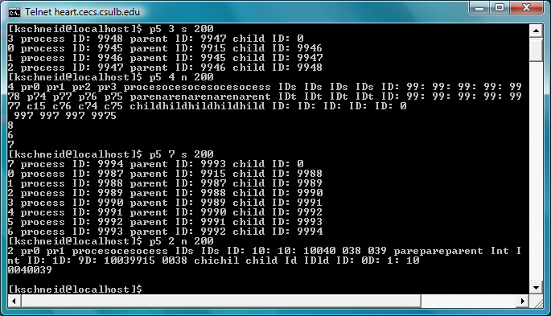

1. P5 3 s 200: Three child processes are created. The original process (9945) creates process 9946. Process 9946 creates process 9947. Process 9947 creates process 9948 and process 9948 does not create a child process. The display looks normal because the semaphore was protecting the critical section. Each process had mutually exclusive access to the standard output and thus was allowed to finish its display prior to another process entering the critical section.
2. P5 4 n 200: Four child processes are created. However, because the semaphore was not used to protect the critical section, it is extremely difficult to read the display. Mutual exclusion of the critical section was violated.
3. P5 7 s 200: This time seven processes are created. The display looks normal because the semaphore was protecting the critical section.
4. P5 2 n 200: This time two processes are created. The display is difficult to read because the semaphore was not protecting the critical section.